Memo
Sydney Central City Planning Panel

Subject: | DA 1541/2021/JP (PPSSCC-241) – Mixed Use Development Comprising of Two Residential Flat Buildings Containing 196 Apartments, Retail, Business, Indoor Recreation and Medical Uses and Basement Car parking.
Site: | 40 Solent Circuit Norwest
Date:  From: | 7 April 2022  Cynthia Dugan, Principal Co-ordinator Development Assessment  The Hills Shire Council

The purpose of this memo is to advise the Sydney Central City Planning Panel of Council Officer’s recommended changes to draft conditions in the Council Assessment Report distributed to the Panel on 30 March 2022.
The Applicant requested changes to the draft conditions on 31 March 2022 (see Attachment A). This request was received after the Council Assessment report was distributed to the Panel. Further correspondence between Council staff and the Applicant has occurred regarding the requested amendments. Subsequently, the following recommended changes are proposed to the draft conditions in the Council Assessment Report. Note that relevant Council Officer Comments have been provided to explain amendments as necessary.
Council Officer’s recommended changes to draft conditions:

- The note under the heading “GENERAL MATTERS” be amended as follows:
GENERAL MATTTERS
Note that all conditions apply to all of Stage 1as indicated on the Staging Plan unless otherwise specified.

- Condition No. 1 be updated to reflect the following references and deletion of landscape plans:
1. Development in Accordance with Submitted Plans
The development being carried out in accordance with the following approved plans and details, stamped and returned with this consent except where amended by other conditions of consent.
The amendments in red require the following:
- The following units are increased in length to ensure that the balcony sizes are at least 10m²:
  - 2 bedroom units Type 1c (units 05.02, 08.02, 11.02, 14.02, 17.02 and 20.02)
  - 2 bedroom units and study Type 1b (Units 7.01, 10.01,13.01, 16.01 and 19.01)
- At least 10% or 20 dwellings are to be adaptable/accessible units

REFERENCED PLANS AND DOCUMENTS
DRAWING NO. | DESCRIPTION | PREPARED BY | REVISION | DATE
A22.201 | Staging Diagrams | Bates Smart | B | 30/09/2021
DA-154 | B04 Plan | Smart Design Studio | D | 25/01/2022
DA-153 | B03 Plan | Smart Design Studio | D | 25/01/2022
DA-152 | B02 Plan | Smart Design Studio | D | 25/01/2022
DA-151 | B01 Plan | Bates Smart | E | 14/03/2022
DA01.101 | Site Plan – Roof Level | Bates Smart | B | 30/09/2021
DA01.102 | Site Plan – Level 1 | Bates Smart | B | 30/09/2021
DA01.103 | Site Plan – Ground Level | Bates Smart | B | 30/09/2021
DA-03.100 | Ground Level Plan | Bates Smart | B | 30/09/2021
DA-03.101 | Level 1 Plan | Bates Smart | B | 30/09/2021
DA-03.101M | Level 1 Mezzanine | Bates Smart | B | 30/09/2021
DA-03.102 | Level 2 Plan | Bates Smart | B | 30/09/2021
DA-03.102M | Level 2 Mezzanine | Bates Smart | B | 30/09/2021
DA-03.103 | Level 3 Plan | Bates Smart | B | 30/09/2021
DA-03.104 | Level 4 Plan | Bates Smart | B | 30/09/2021
DA-03.109 | Floorplate Type A - Level 6, 9, 12, 15, 18 | Bates Smart | B | 30/09/2021
DA-03.110 | Floorplate Type B – Levels 7,10, 13, 16, 19 | Bates Smart | B | 30/09/2021
DA-03.111 | Floorplate Type C Levels 5,8,11,14,17, 20 | Bates Smart | B | 30/09/2021
DA-03.121 | Level 21 Plan | Bates Smart | B | 30/09/2021
DA-03.122 | Level 22 Plan | Bates Smart | B | 30/09/2021
DA-03.123 | Level 23 Plan | Bates Smart | B | 30/09/2021
DA-03.124 | Rooftop Plant Level | Bates Smart | B | 30/09/2021
DA-03.125 | Roof Plan | Bates Smart | B | 30/09/2021
DA-09.001 | North Elevation | Bates Smart | B | 30/09/2021
DA-09.002 | West Elevation | Bates Smart | B | 30/09/2021
DA-09.003 | South Elevation | Bates Smart | B | 30/09/2021
DA-09.004 | East Elevation | Bates Smart | B | 30/09/2021
DA-10.001 | Section A | Bates Smart | B | 30/09/2021
DA-10.002 | Section B | Bates Smart | B | 30/09/2021
DA-10.003 | Section C | Bates Smart | B | 30/09/2021
DA-10.004 | Section D | Bates Smart | B | 30/09/2021
DA-10.005 | Section E | Bates Smart | B | 30/09/2021
DA-10.006 | Section F | Bates Smart | B | 30/09/2021
DA100 | L00 Plan | Smart Design Studio | B | 24/09/2021
DA101 | L01 Plan | Smart Design Studio | B | 24/09/2021
DA102 | L02 Plan | Smart Design Studio | B | 24/09/2021
DA103 | L03 Plan | Smart Design Studio | B | 24/09/2021
DA104 | L04 – 12 Plan | Smart Design Studio | B | 24/09/2021
DA113 | L13 Plan | Smart Design Studio | B | 24/09/2021
DA114 | Roof Plant Plan | Smart Design Studio | B | 24/09/2021
DA115 | Roof Plan | Smart Design Studio | B | 24/09/2021
DA400 | North & West Elevations | Smart Design Studio | B | 24/09/2021
DA401 | South & East Elevations | Smart Design Studio | B | 24/09/2021
DA450 | Section A & B | Smart Design Studio | B | 24/09/2021
- | Norwest Quarter Landscape & Public Domain Report (76 pages) | Aspect Studios | Revised Issue | October 2021
- | Amended Architectural Design Report including materials and finishes | Bates Smart and  Smart Design Studio |  | Uploaded on the planning portal on 8/10/2021
DA100-113 | Numbering Plans | Council’s :Land Information Team | B | Dated 24/09/2021
A03.100-123 | Numbering Plans | Council’ Land Information Team | B | 30/09/2021
No work (including excavation, land fill or earth reshaping) shall be undertaken prior to the issue of the Construction Certificate, where a Construction Certificate is required.
*Council Officer Comment (not to be included in condition):
The landscaping plans have been deleted from condition 1 as the submitted landscape plans and architectural plans do not indicate the same methods to achieve the minimum depths of soil. Conditions 25 and 42 have been recommended to ensure that the landscape and architectural plans are properly co-ordinated prior to the above ground landscape works.

- Condition 11 Property Numbering condition be amended to delete the references to the stages and mailbox cluster section modified.
11. Property Numbering and Cluster Mail Boxes for Multi Dwelling Housing, Residential Flat Buildings, Mixed Use Development, Commercial Developments and Industrial Developments

The responsibility for property numbering is vested solely in Council under the Local Government Act 1993.
The overall property address for this development is: 40 Solent Circuit Norwest.
Building B: 40 Solent Circuit & 1 Natura Rise Norwest
Building C: 42 Solent Circuit Norwest –Residential Units
Approved unit numbering for Smart Design Studio Building B is as per plans submitted marked as DWG No: DA100-113, Rev: B, Dated 24/09/2021 and Bates Smart Building C is as per plans submitted marked as DWG No: A03.100-123, Rev: B, dated 30/9/2021 and marked up as ‘Numbering Plans’ by Council’s Land Information Team within consent documentation; and as follows:
Level | Addresses for Building B | Building B | Building C
Ground | G02: 1 Natura Rise  G01: 40 Solent Cir | G01-G02 | G03
One | 101: 1 Natura Rise  102-105: 40 Solent Cir | 101-105 | 106-109
Two | 1 Natura Rise | 201-207 | 208
Three | 1 Natura Rise | 301-307 | 308-309
Four | 1 Natura Rise | 401-407 | 408-413
Five | 1 Natura Rise | 501-507 | 508-513
Six | 1 Natura Rise | 601-607 | 608-613
Seven | 1 Natura Rise | 701-707 | 708-713
Eight | 1 Natura Rise | 801-807 | 808-813
Nine | 1 Natura Rise | 901-907 | 908-913
Ten | 1 Natura Rise | 1001-1007 | 1008-1013
Eleven | 1 Natura Rise | 1101-1107 | 1108-1113
Twelve | 1 Natura Rise | 1201-1207 | 1208-1213
Thirteen | 1 Natura Rise | 1301-1304 | 1305-1310
Fourteen | - | N/A | 1401-1406
Fifteen | - | N/A | 1501-1506
Sixteen | - | N/A | 1601-1606
Seventeen | - | N/A | 1701-1706
Eighteen | - | N/A | 1801-1806
Nineteen | - | N/A | 1901-1906
Twenty | - | N/A | 2001-2006
Twenty One | - | N/A | 2101-2103
Twenty Two | - | N/A | 2201-2204
Twenty Three | - | N/A | 2301-2304

These addresses shall be used for all correspondence, legal property transactions and shown on the final registered Deposited Plan/Strata Plan lodged with Land Registry Services NSW as required.
Under no circumstances can unit numbering be repeated or skipped throughout the development regardless of the building name or number.
Approved numbers, unless otherwise approved by Council in writing, are to be displayed clearly on all door entrances including stairwells, lift and lobby entry doors.
External directional signage is to be erected on site at driveway entry points and on buildings to ensure that all numbering signage throughout the complex is clear to assist emergency service providers locate a destination easily & quickly.
Mail Boxes
Approval from Australia Post is required to be submitted to Council regarding the approved positions of the Mail Rooms indicated on the plans, contact Australia Post, Gregory Dimmock, email:gregorydimmock@auspost.com.au.
The number of mail boxes to be provided is to be equal to the number of units plus one (1) for the proprietors of the development and be as per Australia Post size requirements.
Strata Developments
All approved developments that require subdivision under a Strata Plan, must submit a copy of the final strata plan to Council’s Land Information Section before it is registered for the approval and allocation of final property and unit numbering. This applies regardless of whether the PCA is Council or not.
It is required that Lot numbers within the proposed strata plan are not duplicated and all run sequentially within the same level, commencing from the lowest level upwards to the highest level within the development.
Please call 9843 0555 or email a copy of the final strata plan before it is registered at Land Registry Services NSW to council@thehills.nsw.gov.au for the approval of final Property and Unit numbering with corresponding Lot Numbers now required to be included within the registered Strata Administration sheet.
Under no circumstances is the Strata Plan to be lodged with Land Registry Services NSW before Council has approved all final addressing.

3. The amendment to Condition 16 as follows:
16. Provision of Kitchen Waste Storage Cupboard
Waste storage facility must be provided in each unit/dwelling to enable source separation of recyclable material from residual garbage. Each unit/dwelling must have a waste storage cupboard provided in the kitchen with at least 2 removable indoor bins with a minimum combined capacity of 30 litres. The bins provided should allow convenient transportation of waste from the kitchen to the main household bins or waste disposal point. The Principal Certifying Authority must visually confirm in person, or receive photographic evidence validating this requirement, prior to the issue of any Occupation Certificate.

4. The amendment to Condition 18 as follows:
18. Construction of Separate Waste Storage Areas
The development must incorporate separate dedicated waste storage areas, to facilitate the separation of residential waste and recycling from commercial material, designed and constructed in accordance with the following requirements. The central residential waste room must provide minimum storage facility for 22 x 1100 litre garbage and 22 x 1100 litre recycle bins. The central retail room must provide minimum storage facility for the total minimum required number of bins to service the premises including any waste infrastructure such as compactors for commercial components.
- The waste storage areas must be of adequate size to comfortably store and manoeuvre the total minimum required number of bins and associated waste infrastructure as specified above.
- The layout of the waste storage areas must ensure that each bin is easily accessible and manoeuvrable in and out of the areas with no manual handling of other bins. All internal walkways must be at least 1.5m wide.
- The design of the waste storage areas must ensure that commercial tenants do not have access to the residential waste storage areas, and vice versa for residential occupants.
- The walls of the waste storage areas must be constructed of brickwork or masonry.
- The floor of the waste storage areas must be constructed of concrete with a smooth non-slip finish, graded and drained to sewer. The rooms must not contain ramps and must be roofed (if located external to the building).
- The waste storage areas must have a waste servicing door, with a minimum clear floor width of 1.5m. The door must be located to allow the most direct access to the bins by collection contractors. Acceptable waste servicing doors are single or double swinging doors and roller doors (preferred).
- The waste servicing door for the residential waste storage area must be must be supplied with a lock through Council’s Waste Management Master Key System ‘P3520’. See condition titled ‘Installation of Master Key System to Waste Collection Room’ for further details.
- The residential waste storage area must have a resident access door, which allows wheelchair access for adaptable sites. Suitable resident access doors are single or double swinging doors. The resident access door must be separate to the waste servicing door. If a loading dock is proposed in the development the resident access door must be located to ensure that residents do not have access to the loading dock to gain access to the waste storage areas.
- All doors of the waste storage areas, when fully opened, must be flush with the outside walls and must not block or obstruct car park aisles or footways. All doors must be able to be fixed in position when fully opened.
- The waste storage areas must be adequately ventilated (mechanically if located within the building footprint). Vented waste storage areas should not be connected to the same ventilation system supplying air to the units.
- The waste storage areas must be provided with a hose tap (hot and cold mixer), connected to a water supply. If the tap is located inside the waste storage areas, it is not to conflict with the space designated for the placement of bins.
- The waste storage areas must be provided with internal lighting such as automatic sensor lights.
- The maximum grade acceptable for moving bins for collection purposes is 5%. Under no circumstance is this grade to be exceeded. It is to allow the safe and efficient servicing of bins.
- The waste storage areas must have appropriate signage (Council approved designs for residential and NSW EPA for commercial), mounted in a visible location on internal walls and are to be permanently maintained by the Owners Corporation.
- Finishes and colours of the waste storage areas are to complement the design of the development.
Example Bin Measurements (mm)
240L: 735 (d) 580 (w) 1080 (h) 660L: 850 (d) 1370 (w) 1250 (h) 1100L: 1245 (d) 1370 (w) 1470 (h)

5. The amendment to Condition 24 as follows:
24. Tree Removal on Public Land
Approval is granted for the removal of eighteen (18) street trees numbered 33-50 within the Arboricultural Impact Assessment prepared by Australis Tree Management dated 16/04/2021 located adjacent Solent Circuit, and two (2) additional street trees adjacent Spurway Drive as located in red on Site Plan Level 1 (DA01.102) revision B dated 30/09/2021 prepared by Bates Smart. The trees are located on the Council nature strips and will be impacted by works associated with the development.
All tree works must be undertaken by the owner/applicant at their cost. Prior to any works commencing on site, the owner/applicant must provide the following details to The Hills Shire Council’s Manager – Environment & Health:
- Time and date of when the tree works will occur;
- Full details of the contractor who will be undertaking tree works (Minimum AQF level 3 Arborist);
- Current copy of the contractors Public Liability Insurance (Minimum $10,000,000).
Note: The owner/applicant is to keep a photographic record pre and post tree removal works of the tree and surrounding Council infrastructure (e.g. concrete footpath, kerb & gutter) and provide these to Council upon request. The grass verge must be reinstated with any holes filled to existing natural ground level.

6. The amendment to Condition 25 as follows:
25. Planting Requirements
All trees are to be planted as part of the approved landscape plan pursuant to condition 42 of this consent. Groundcovers are to be planted at 5/m2.
For all planting on slab and planter boxes, the following minimum soil depths must be achieved:
• 1.2m for large trees, 1m for medium trees and 800mm for small trees.
• 500-600mm for shrubs
• 200-450mm for groundcovers; and
• 200mm for turf.
7. The amendment to Condition 35 as follows:
35. Vehicular Access and Parking Stage 1A
The formation, surfacing and drainage of all driveways, parking modules, circulation roadways and ramps are required, with their design and construction complying with:
- AS/ NZS 2890.1
- AS/ NZS 2890.6
- AS 2890.2
- DCP Part C Section 1 – Parking
- Council’s Driveway Specifications
Where conflict exists the Australian Standard must be used.
The following must be provided:
- All driveways and car parking areas must be prominently and permanently line marked, signposted and maintained to ensure entry and exit is in a forward direction at all times and that parking and traffic circulation is appropriately controlled.
- All driveways and car parking areas must be separated from landscaped areas by a low level concrete kerb or wall.
- All driveways and car parking areas must be concrete or bitumen. The design must consider the largest design service vehicle expected to enter the site. In rural areas, all driveways and car parking areas must provide for a formed all weather finish.
- All driveways and car parking areas must be graded, collected and drained by pits and pipes to a suitable point of legal discharge.
- Basement 3 and 4 shall be restricted to residential parking only and a boom gate or roller shutter will need to be provided. This requirement shall be shown on architectural plans.
- A boom gate at the beginning of the dead-end aisle in B2 is required to stop the visitors from access the dead-end aisle in B2. This requirement shall be shown on architectural plans
- The proposed roller shutter for the service vehicle entry shall be relocated within the proposed RAMP to ensure that the HRV will wait on the ramp. Queuing on Solent Circuit will not be permitted.
- The proposed roller shutter for the carpark entry shall be removed or relocates within the proposed RAMP to ensure that the vehicles will wait on the Ramp. Queuing on Solent Circuit will not be permitted. This shall comply with section 3.4 and 3.5 of AS/ NZS 2890.1.
- A Loading dock management plan shall be prepared by a qualified traffic engineer to ensure that the entering vehicles through the service vehicle entry will have priority.
- A design compliance certificate prepared by a qualified traffic engineer satisfying the requirements above shall be reflected on the Construction Certificate plans and supporting documentation prior to the release of the Construction Certificate.

8. The deletion of Condition 31:
31. Recycled Water – Rouse Hill/ Sydney Water
The subject site must be connected to Sydney Water’s Rouse Hill Recycled Water Scheme, unless written evidence from Sydney Water is submitted advising that this service is not available.

9. The amendment to Condition 39 as follows:
39. Design Verification of residential units
Prior to the release of the Construction Certificate design verification is required from a qualified designer to confirm the development is in accordance with the approved plans and details and continues to satisfy the design quality principles in SEPP65.

10. The deletion of Condition 40:

11. The amendment to Condition 42 as follows:
42. Landscape Plan – Prior to Aboveground Landscape Works
An Amended Landscape Plan (to scale) for the landscaping of the site is to be prepared by a suitably qualified landscape architect or landscape designer and submitted to the satisfaction of Council’s Manager - Environment and Health. The plan must contain:
a) site boundaries and dimensions surveyed;
b) north point, and scale (1:200 desirable);
c) existing and proposed levels;
d) all trees, grassed areas, landscape features and main structures on the site (buildings, car parking, driveways, walls, fences, paving, etc)
e) all landscape materials, such as landscape surfaces, retaining walls, fencing etc;
f) a detailed planting plan indicating all proposed planting, which avoids the use of large planting ‘mixes’;
g) a schedule of proposed planting, including botanical names, common names, quantities, pot size, expected mature height and staking requirements;
h) landscape sections with associated section markers to demonstrate the minimum soil depths achieved over the basement slab and on podium planting;
i) demonstration of depth of soil for planting over basement and podium indicated using finished slab levels, proposed levels, and Top of Wall levels. Depth of soil must meet the following depths without the use of steep mounding:
• 1.2m for large trees, 1m for medium trees and 800mm for small trees.
• 500-600mm for shrubs
• 200-450mm for groundcovers; and
• 200mm for turf;
j) depth of soil consistent between landscape and architectural plans. Depth of soil achieved by the use of retaining wall height and/or deepened slabs are to be consistent between architectural and landscape plans submitted prior to construction certificate;
k) demonstration that soil battering of no greater than 1:3 slopes are provided within landscaped areas; and
l) planting to screen high retaining walls located between Building B and C which are visible from Solent Circuit.
12. The amendment to Condition 51 as follows:
51. Drained Basement– Stage 1A

The basement must be protected from flooding/groundwater impacts. Whether tanked or not, the design of the basement must comply with the Design and Building Practitioners Act 2020.
During construction, a Dewatering Management Plan should be prepared which would outline monitoring and testing required to assess quality of groundwater prior to discharge in accordance with NSW Department of Natural Resources Access Regulator (NRAR) requirements.
Design details and construction specifications shall be included in the documentation accompanying the Construction Certificate in accordance with the submitted Groundwater Take Assessment uploaded on the planning portal on 31 January 2022. .
Prior to the issue of the Construction Certificate, the consent holder must submit a design compliance certificate prepared by suitably experienced Chartered structural Engineer satisfying the requirements above to the Registered Principal Certifier. These requirements shall be reflected on the Construction Certificate plans and supporting documentation
*Council Officer Comment (not to be included in condition):
Clause 4.46 of the Environmental Planning and Assessment Act 1979 prescribes that integrated development is development that, in order for it to be carried out, requires development consent and additional approvals including a water use approval, water management work approval or activity approved under Part 3 of Chapter 3 in Sections 89, 90 and 91 of the Water Management Act 2000.
Section 91 of the Water Management Act 2000 prescribes that there are two kinds of activity approvals, namely, controlled activity approvals and aquifer interference approvals. The proposal will result in groundwater take during the construction and operational phases of the development which constitutes an aquifer interference activity typically requiring a Water Access Licence (WAL). The Applicant did not nominate the Development Application as integrated development under the Act and did not indicate that the development is exempt from the requirement of a Water Access Licence approval.
In order to protect the basement from flooding/groundwater impacts, Council staff originally recommended the tanking of basements as a waterproof retention system in conditions 51 and 99 as this is best practice. These conditions were also recommended to ensure that the Development Application would not require an approval under Section 91 of the Water Management Act 2000. However, the Applicant has requested the requirement of tanking the basement in conditions 51 and 99 be deleted. Reference was made to the submitted Ground Water Assessment prepared by EA Investigations uploaded on the planning portal on 31 January 2022 which concluded that tanking of the basement was not required and a pump out system was sufficient to deal with any groundwater penetration in the basement area.
Since the Applicant’s request to modify these conditions, Council staff have identified that the Ground Water Take Assessment also concludes that the groundwater take is less than 3ML per year during both construction and operation and this would meet the exemptions from obtaining a Water Access Licence (WAL). It is on this basis that development consent can be issued without separate approval from The Natural Resources Access Regulator (NRAR) and the Development Application is not considered to be integrated development. The Applicant was advised of this and in response, the following was confirmed by the Applicant on 6 April 2022:
“Based on the development documentation provided and the subsequent Groundwater Take Assessment prepared, consultation with NSW Department of Natural Resources Access Regulator (NRAR) is not required for dewatering of less than 3ML per annum. However, in order to provide guidance for dewatering contractors during construction, a Dewatering Management Plan should be prepared which would outline monitoring and testing required to assess quality of groundwater prior to discharge.”
In this regard, it is recommended that condition 51 be amended as above and condition 99 is deleted.
13. The amendment to Condition 83 as follows:
83. Provision of Signage for Waste Storage Areas
Prior to any Occupation Certificate being issued, a complete full set of English waste education signage (garbage, recycling and no dumping) must be installed in a visible location on every internal wall of all waste storage areas. Additionally, one set of English and garbage and recycling signage must be provided above every chute opening on every floor. The signage must meet the minimum specifications below and must be designed in accordance with Council’s approved artwork. Waste signage artwork can be downloaded from Council’s website; www.thehills.nsw.gov.au.

- Flat size: 330mm wide x 440mm high
- Finished size: 330mm wide x 440mm high. Round corners, portrait
- Material: Aluminium / polyethylene composite sheet 3.0mm, white (alupanel)
- Colours: Printed 4 colour process one side, UV ink
- Finishing: Over laminated gloss clear. Profile cut with radius corners and holes.

14. The amendment to Condition 98 as follows:
98. Certification stormwater drainage
Prior to the issue of any Occupation Certificate, a submission of written certification from a suitably qualified civil engineer stating that all stormwater drainage and related works within the subject site have been constructed in accordance with the approved Construction Certificate plans, the conditions included within this consent, the requirements of AS/NZS 3500.3:2018, and Council’s Design Guidelines Subdivision/Developments dated September 2011.

15. The deletion of Condition 99:

Council Officer’s response to Applicant’s request to amend conditions 1, 7 and 35
*Note: Applicant’s requested changes in blue:

- Condition 1
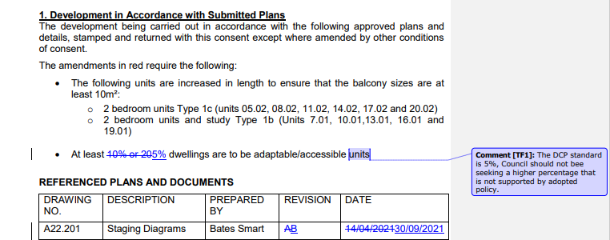

Council Officer response: Not supported. Refer to Section 6c of Council Assessment Report. DCP amendments to Access and Adaptability controls came into force on 21 May 2019 following Council resolution on 30 April 2019 to adopt the draft amendments as a response to requirements of The Hills Disability Inclusion Action Plan. The amendments include an increase in the percentage of adaptable/accessible housing from 5% to 10% under Part B Section 5 Residential Flat Buildings. The proposal was lodged after the adoption of the DCP. The submitted Accessibility Report incorrectly refers to the previous 5% requirement which is not current. Therefore amendment in red to condition 1 is recommended to remain as required under Council’s adopted DCP.

- Condition 7
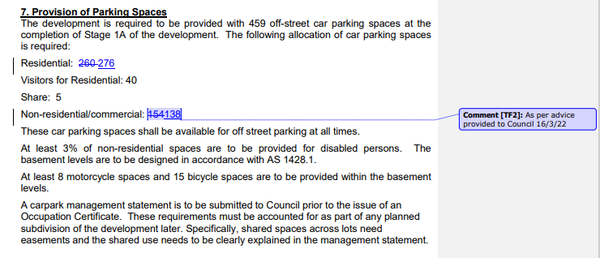
The following further response is provided by the Applicant on 6 April 2022:
The development application presented a unique opportunity to address traffic congestion and to make best use of the metro, interchange facilities, metro connect bus service, the rapid and suburban bus network, improving walking connectivity and cycleway links and facilities in the precinct. At ultimate development, the Central and Eastern Precincts of the Norwest Town Centre Residential area will have 12 buildings including the three completed buildings to the west of Natura Rise, with a potential of 1,040 units with a population of between 2,500 and 3,000 residents. Not to mention Sekisui and the future development of Marketown.
Given the non-residential components within Buildings B & C will also be used in part by these and other residents, and therefore would not generate additional parking or trips, the Traffic Report proposed a 20-25% target mode share to be from walking patrons (see Table 5 - Targets for Mode Share and supported by an Integrated Transport Strategy for Norwest – Appendix A to the Traffic Report). While these targets are well below the target stipulated in the Bella Vista Station Precinct Finalisation Report (2017) prepared by TfNSW, of an ultimate mode share goal of 53% for public and active transport for trips made both, to and from the precinct, they are a significant step to addressing traffic congestion and travel behaviour in the developing transit-oriented development of Norwest.
Amendment:-
Residential – 276
Visitors for Residential - 40
Share – 5
Non-residential/commercial -138
Council Officer response: Not supported. Refer Section 6d. of the Council Assessment Report. The Development Application proposes a shortfall of 16 non-residential/commercial spaces and a surplus of 80 residential spaces to the minimum requirements in the DCP. To ensure full compliance with the DCP controls and sufficient parking is provided for the non-residential land uses on the site, it is recommended that 16 of the residential spaces be reallocated for non-residential uses as recommended in condition 7 in the Council Assessment Report. It is noted that the Project Coordination Group consisting of Council staff and officers from DPE and Transport for NSW, are undergoing traffic modelling for strategic centres within The Hills including Norwest. Council staff do not recommend support of a variation to Council’s adopted DCP controls for non-residential land uses within the Norwest Strategic Centre prior to the completion of this traffic modelling work.

- Condition 35
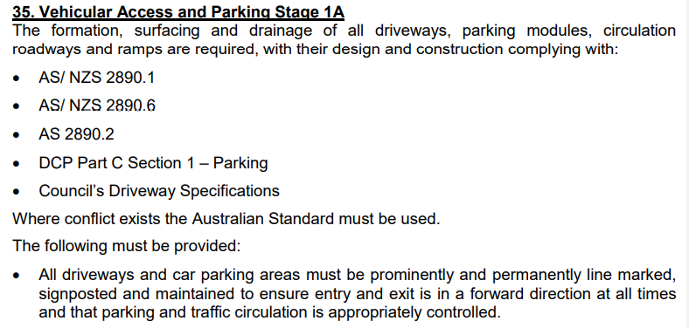
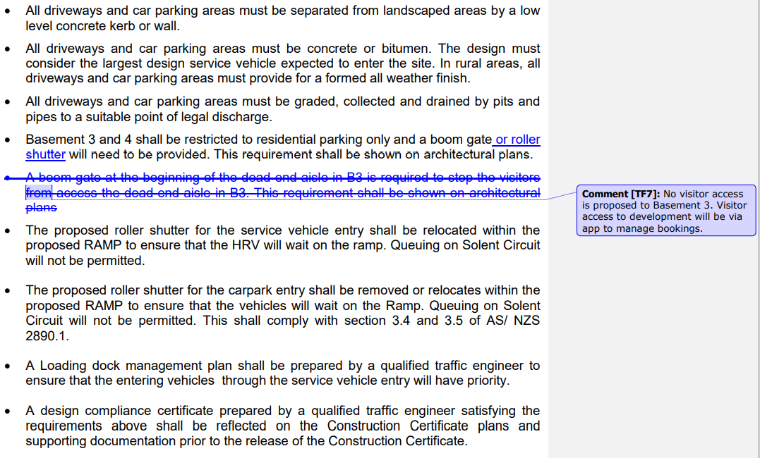

Council Officer response: Deletion of condition not supported. Incorrect reference made to B3. Correct reference is to B2 which is recommended to be amended. Refer to amended condition 35 in the section above.

Attachment A: Applicants requests to change draft conditions submitted on 31 March 2022